Nama : Adridinan Najmi Faza
NIM : H1D025059
Shift Awal/Akhir : B/H
Test Akhir

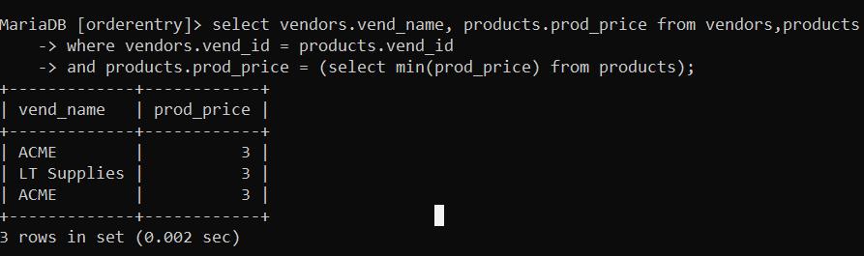
- Carilah nama vendor yang harga barangnya termurah.
MariaDB [orderentry]> select vendors.vend_name, products.prod_price from vendors,products
-> where vendors.vend_id = products.vend_id
-> and products.prod_price = (select min(prod_price) from products);
+-------------+------------+
| vend_name | prod_price |
+-------------+------------+
| ACME | 3 |
| LT Supplies | 3 |
| ACME | 3 |
+-------------+------------+
3 rows in set (0.002 sec)

- tampilkan kota -kota dari vendor product jetpack harganya dibawah 55.
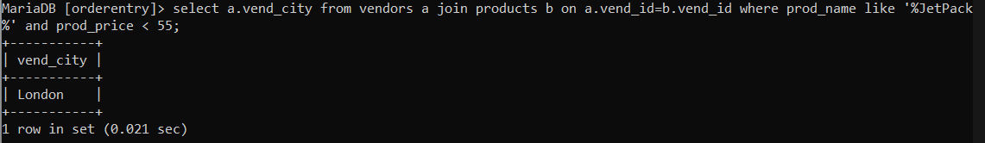
MariaDB [orderentry]> select a.vend_city from vendors a join products b on a.vend_id=b.vend_id where prod_name like '%JetPack%' and prod_price < 55;
+-----------+
| vend_city |
+-----------+
| London |
+-----------+
1 row in set (0.021 sec)
- siapa sajakah customer yang melakukan order tanggal 01-09-2005
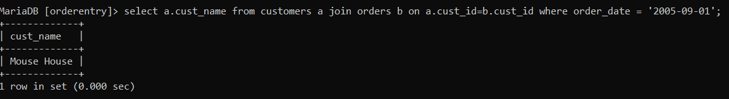
MariaDB [orderentry]> select a.cust_name from customers a join orders b on a.cust_id=b.cust_id where order_date = '2005-09-01';
+-------------+
| cust_name |
+-------------+
| Mouse House |
+-------------+
1 row in set (0.000 sec)
- dimanakah alamat lengkap customer(Kota,negara,kodepos) yang melakukan pembelian barang sama dengan customer no 10002 ?
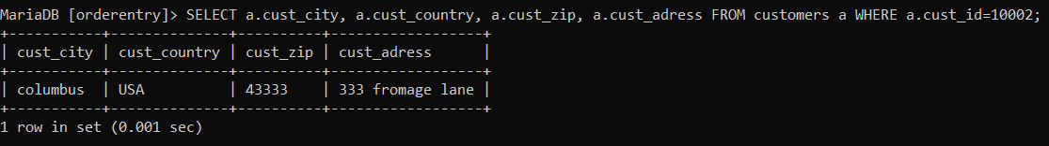
MariaDB [orderentry]> SELECT a.cust_city, a.cust_country, a.cust_zip, a.cust_adress FROM customers a WHERE a.cust_id=10002;
+-----------+--------------+----------+------------------+
| cust_city | cust_country | cust_zip | cust_adress |
+-----------+--------------+----------+------------------+
| columbus | USA | 43333 | 333 fromage lane |
+-----------+--------------+----------+------------------+
1 row in set (0.001 sec)
- siapakah nama customer dan email contaknya, yang paling boros belanja ( dilihat dari pembelian barang paling banyak) ?
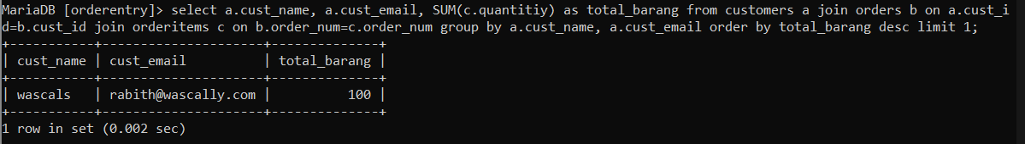
MariaDB [orderentry]> select a.cust_name, a.cust_email, SUM(c.quantitiy) as total_barang from customers a join orders b on a.cust_id=b.cust_id join orderitems c on b.order_num=c.order_num group by a.cust_name, a.cust_email order by total_barang desc limit 1;
+-----------+---------------------+--------------+
| cust_name | cust_email | total_barang |
+-----------+---------------------+--------------+
| wascals | rabith@wascally.com | 100 |
+-----------+---------------------+--------------+
1 row in set (0.002 sec)

